**Draft Final Report**

Long-Term Fiscal Health Analysis

**Prepared for:**

City of Sparks

**Prepared by:**

Economic & Planning Systems, Inc.

EPS #173111

July 29, 2019

Table of Contents

1. Introduction and Summary of Findings 1

Introduction 1

Summary of Findings 2

2. Future Development Demand 5

Recent Growth Trends 5

Housing Demand 14

Non-Residential Demand 20

3. Development Capacity 30

Land Capacity 30

Comparison of Demand to Land Supply 36

4. Long-Term Fiscal Impacts 41

Baseline Forecast Fiscal Impact 41

Fiscal Impact Alternative Scenarios 45

List of Tables

Table 1. City of Sparks Population and Households, 2000 to 2018 7

Table 2. City of Sparks Residential Permitted Units, 2010 to 2018 14

Table 3. Washoe County Consensus Population Forecast, 2017 to 2038 17

Table 4. City of Sparks Population and Household Forecast, 2017 to 2038 17

Table 5. City of Sparks New Housing Demand, 2017 to 2038 18

Table 6. City of Sparks Residential Land Demand, 2017 to 2038 19

Table 7. Regional Office Inventory, 2010 to 2018 21

Table 8 Regional Industrial Inventory, 2010 to 2018 22

Table 9. Regional Retail Inventory, 2010 to 2018 24

Table 10. Washoe County Consensus Employment Forecast, 2018 to 2038 26

Table 11. Washoe and Storey County Employment Forecast, 2018 to 2038 27

Table 12. Non-Residential Uses Development Factors 28

Table 13. Forecast Regional New Development Demand, 2018 to 2038 28

Table 14. Sparks Development Capture Rates 29

Table 15. Sparks Development and Land Demand, 2018 to 2038 29

Table 16. Sparks Vacant Acres by Land Use Designation 31

Table 17. Housing and Employment Use Capacity by Land Use Category 32

Table 18. Sparks Comprehensive Plan Land Use Translations 33

Table 19. Land Capacity for Non-residential Uses 35

Table 20. Summary of Estimated Land Demand, 2018 to 2038 36

Table 21 Comparison Land Demand to Capacity 39

Table 22. 20-Year Fiscal Impact of Baseline Forecast 43

Table 23 Fiscal Impact of Alternative Scenarios 46

List of Figures

Figure 1. Change in Population, Sparks, 1990 to 2018 8

Figure 2. Reno-Sparks MSA Employment, 1990 to 2018 9

Figure 3. Reno-Sparks MSA Employment, 1990 to 2018 10

Figure 4. Washoe County Employment Change by Industry, 2010 to 2017 12

Figure 5. Storey County Employment Change by Industry, 2010 to 2017 13

Figure 6. Regional Office Vacancy Rate, 2007 to 2018 21

Figure 7 Regional Industrial Vacancy Rates, 2007 to 2018 23

Figure 8 City of Sparks Industrial Inventory, 2007 to 2018 23

Figure 9. Regional Retail Vacancy Rates, 2007 to 2018 25

Figure 10 Sparks Developable Land Capacity 40

Figure 11 Baseline Forecast Annual Net Fiscal Impact (30 years) 44

1. Introduction and Summary of Findings

# Introduction

The fiscal health of large Nevada cities is tenuous. Cities have limited power and control over revenue generation due to Nevada law. State taxation laws have created a situation where cities must rely on new development to sustain fiscal health. Sparks is experiencing significant amounts of new development as the region rebounds from the Great Recession. Increased development demand in recent years has resulted in owners/developers seeking to annex into the city of Sparks or seek Comprehensive Plan land use amendments for large parcels. Comprehensive Plan land use amendments are often requested for parcels currently designated for employment and commercial land uses. The City considers employment and commercial uses to be important for maintaining the long-term fiscal health of the City. As a result, the City requires applicants to prepare a fiscal impact analysis for some land use project approvals (e.g., large annexations or Comprehensive Plan land use amendments). The purpose of this analysis is to document the associated costs and revenues and to understand the overall impact of the proposed development on the City.

Fiscal balance and health cannot be achieved on a project by project basis. Thus, approving development projects based solely on the evaluation of the fiscal impact can be problematic in some cases. The reality is, some projects will generate a net negative impact while others a positive one. The City of Sparks wants to understand how different uses impact its long-term fiscal health, providing a basis to determine the fiscal implications of the current land use plan and to help the City review proposed changes to Planned Developments (PDs), land use plan amendments, and annexations.

This report is a summary of the analysis of the long-term fiscal impact of the City’s approved Comprehensive Plan land use plan and how changes to this land use plan may impact the City. The report contains three sections:

* **Estimate of Future Development Demand:** This chapter summarizes the estimated future development demand in the City over the next 20 years.
* **Estimate of Development Capacity**: This chapter summarizes estimated land capacity for new development in the City, which is compared to the estimated demand.
* **Long-Term Fiscal Impacts:** The last chapter compares the fiscal impact of the growth forecasts and associated development demand on the City of Sparks over a 20-year planning horizon. Alternative growth scenarios are also evaluated to illustrate how land use decisions impact long term fiscal health.

This report is a part of a larger effort undertaken by the City of Sparks related to the fiscal impact of new development and land use decisions. The City hired Economic & Planning Systems (EPS) to develop a fiscal impact model to analyze proposed development within the City. EPS developed guidelines for applicants to follow when submitting a fiscal impact analysis for a development proposal. The fiscal impact guidelines, as well as the methodology and factors used in that model, are summarized in a separate memorandums.

# Summary of Findings

The major findings developed through the analysis are summarized below.

1. The region (defined as Washoe and Storey Counties) was hit hard by the economic recession in 2008 and 2009. However, it has recovered and is growing at an increasing rate.

Employment growth has returned and now exceeds rates of growth experienced in the 1990's and early 2000's. Industrial oriented industries (transportation and warehousing, manufacturing, administrative services) and service-oriented industries (health care, retail, accommodations and food service) have led the economic rebound. Industrial uses have generated the most development activity. The region added over 15 million square feet of new industrial space, of which only 1.8 million square feet was built in the City of Sparks. Storey County has emerged as an employment growth center with the addition of the Tesla "Gigafactory" and the Truckee-Reno Industrial Center. Retail development activity has been slower to rebound and only started increasing in the past three to four years as housing inventory has been added. New office development has been minimal since the recession.

1. Employment in the region and Sparks is forecast to steadily continue over the next 20 years with growth in industrial, service, and tourism-oriented industries.

The region is forecast to add more than 94,000 jobs over the next 20 years at an annual rate of 1.4 percent. The forecast employment growth will generate demand for over 51 million square feet of commercial and industrial development. The city of Sparks is estimated to capture approximately 25 percent of non-residential development, which equates to 9.1 million square feet of new commercial and industrial space. The estimated development will generate demand for 961 acres of land.

1. The region has been adding new residents at a slower rate since 2010 than experienced in the 1990's and early 2000's, but has increased at a greater rate in recent years as employment growth has steadily increased.

Annual population growth in the region and Sparks has been significantly lower since 2007, as compared to the rates experienced prior to the economic recession. The city of Sparks has grown in population at an annual rate of 1.4 percent since 2010, but grew by over 3 percent a year in the 17 years prior to 2007. New housing development has begun to pick up due to employment growth but still lags pre-recession levels. The City of Sparks has permitted an average of 586 residential units since 2010, and has permitted over 1,122 units per year since 2015; with a peak of activity in 2017 (1,664 permitted units).

1. City of Sparks and Washoe County population is forecast to grow at a slower rate than employment over the next 20 years.

Washoe County and Sparks are expected to increase in population at an annual rate of 1.0 percent adding 23,180 residents to Sparks and 106,000 residents to the County in total. (As noted previously, employment growth through 2040 is forecast at 1.4 percent, which is 40 percent higher than the 1.0 rate estimated for residential). The forecast population growth will generate demand for approximately 12,200 new housing units in Sparks, which will require approximately 1,800 acres of land.

1. Sparks has an adequate amount of vacant, developable land in aggregate to accommodate forecast growth over the next 20 years; however, there is lack of capacity for some uses.

With an estimated 3,847 acres of vacant land, the City has land capacity for most uses based on its Comprehensive Plan land use designations. Industrial and moderate density single family uses will account for the majority of the estimated demand for these uses. Based on the current Comprehensive Plan land use plan, there is insufficient land designated for these two types of uses. However, the moderate density single family development can also be accommodated on parcels designated for low-density single family and/or high-density single family/low-density multifamily as there is excess capacity designated for these uses. Industrial lands, especially development-ready sites, are more limited in the Sparks and the region as a whole. However, the City has an excess of land for office and retail uses, which allows for flexibility for conversion to other uses, especially other employment-generating uses.

1. The baseline forecast and Comprehensive Land Use Plan are estimated to generate a positive fiscal impact to the City's General Fund over the next 20-years. This surplus will likely be off-set by deficits created in the Road Fund. The net fiscal condition of the City will be negative, although the two funds are distinct.

The new development generated by the baseline forecast for the City of Sparks will generate an *annual* net positive fiscal impact of $3.3 million. However, the Road Fund is estimated to have an annual net negative fiscal impact of $4 million.

1. A denser development pattern and increased development of employment-oriented uses were found to create better fiscal conditions with lower impacts to the City’s finances.

Four alternative growth scenarios were tested to understand the impacts of varied growth patterns. Alternatives with density factors 10 percent greater than the baseline forecast and with increased industrial or office development were found to generate more revenue and lower expenditures. A balanced growth pattern between residential and employment uses is needed to maintain fiscal health.

1. Future Development Demand

This section provides an estimate of development demand for Sparks over the next 20 years. EPS analyzed recent growth and development trends for housing, retail, office and industrial space in the region to understand Spark’s historic rate and capture of new development. Forecasts by the State Demographer, the Truckee Meadows Regional Planning Agency Consensus Forecast, and as part of EDAWN’s EPIC Study are used to estimate population and employment growth in the region. Forecast growth is translated into demand for new housing units and non-residential space (in square feet). Lastly, EPS used capture rates to forecast demand for new buildings and land within the city of Sparks.

# Recent Growth Trends

Population and Households

Sparks and Washoe County have increased in population at a steady rate over the past two decades. Sparks has added 10,946 new residents since 2010, as shown in

**Table** 1. This represents 26 percent of population growth in the county since 2010. Sparks outpaced the rate of growth in Washoe County from 2000 to 2018, but since 2010 has matched the county’s overall rate of 1.4 percent annually.

Table 1. City of Sparks Population and Households, 2000 to 2018



The rate of population growth in Sparks has decreased since 2010 from rates experienced in the 1990’s and 2000’s. Sparks increased in population at an annual rate of over 3.0 percent in the 1990’s and 2000’s, as shown in **Figure 1**,falling to 1.4 percent in the recent past.

Figure 1. Change in Population, Sparks, 1990 to 2018



## Employment

The Reno-Sparks Metropolitan Statistical Area (MSA) is comprised of Washoe and Storey Counties. Washoe County has the major economic centers in the MSA and accounts for 95 percent of employment in the MSA. Economic growth in Washoe County is supported by four main economic drivers. The region has been a major tourism center anchored by casino gaming and proximity to Lake Tahoe and the associated outdoor recreational activities. Washoe County is also a regional health services and retail hub serving the greater northern Nevada area and the mountain communities to the west in California. The Reno-Sparks MSA is a major distribution and logistics center due to its proximity to several major metro areas and access to I-80. Lastly, the University of Nevada-Reno and other educational institutions also serve as economic anchors.

Total 2018 employment in the Reno-Sparks MSA was 254,600, as shown in **Figure 2**.The Great Recession had a tremendous adverse impact on the economy of the MSA. Employment in the MSA was growing steadily from 1990 to 2006; however employment declined by 16 percent from 2006 to 2011. Not until 2015 did total employment in the MSA exceed 2005 totals.

Figure 2. Reno-Sparks MSA Employment, 1990 to 2018



Employment grew by 3.2 percent annually with 5,360 jobs added per year in the 1990’s. Employment declined by an average of 650 jobs per year from 2000 to 2010 despite strong employment growth in the first five years of the decade. Since 2010, employment has rebounded and is outpacing the amount of new jobs annually added in the 1990’s as show in **Figure 3**,with nearly 7,800 jobs per year.

Figure 3. Reno-Sparks MSA Employment, 1990 to 2018



As reflected in **Figure 4**, employment growth in Washoe County has been driven by growth in the construction, distribution and warehousing, and administrative sectors. The construction industry has grown the most in employment since 2010, adding 7,307 jobs after losing over 14,700 jobs from 2006 to 2010. The transportation and warehousing and administrative services industries collectively added over 10,000 jobs since 2017—accounting for a third of the county’s total employment growth. The administrative services industry includes back office uses, call centers, and temporary worker providers. A significant portion of the administrative services jobs in Washoe County are related to temporary jobs supporting the distribution-oriented companies, such as Amazon, located in the county. The tourism and service industries (accommodations and food service, retail trade, and health care) also experienced strong employment growth, adding nearly 10,000 jobs since 2010 and accounting for another third of employment growth. Manufacturing and professional services also grew significantly, adding 2,385 and 1,820 jobs respectively, since 2010

Figure 4. Washoe County Employment Change by Industry, 2010 to 2017



Storey County had a small employment base until recent years. This changed with the emergence of the Tahoe-Reno Industrial Center (TRI Center), a large logistics and manufacturing industrial center. Electric car maker Tesla built its “Gigafactory” lithium ion battery manufacturing center at the TRI Center, just west of the Washoe County border. The factory, which opened in 2016, has a total potential size of up to 10 million square feet. According to the State of Nevada’s Governor’s Office of Economic Development (GOED) impact analysis completed in 2014, the factory will be home to 6,500 jobs. Storey County grew by 3,581 manufacturing jobs and 2,963 transportation and warehousing jobs from 2010 to 2017. The county has also had a large increase in construction jobs (1,422) to support the growth at the TRI Center.

Figure 5. Storey County Employment Change by Industry, 2010 to 2017



# Housing Demand

This section contains a summary of the estimated demand for housing and land for housing over the next 20 years. EPS used the Truckee Meadows Regional Planning Agency’s (TMRPA) Consensus Forecast to develop estimated demand for housing. Recent development trends were used to estimate the demand by housing type.

## Development Trends

The City of Sparks permitted 5,270 residential units from 2010 to 2018, as shown in **Table 2**.The City issued an average of 586 residential building permits per year during this period. Single family detached homes accounted for 60 percent of the units permitted, with an average of 352 units per year. Multifamily units—defined as units with five units or more in a structure—accounted for 39 percent, and attached single family units accounted for 1 percent of units. Permit activity increased significantly in 2015 with 851 units permitted that year. In 2017, Sparks permitted 1,664 units, which is three times the average number permitted annually over the nine-year span from 2010 through 2018. Nearly all of this increase is attributable to the development of multi-family housing, including new apartment communities located in the city’s Victorian Square and Sparks Marina redevelopment areas.

Table 2. City of Sparks Residential Permitted Units, 2010 to 2018



## Population Growth Forecast

TMRPA is required to develop a Consensus Forecast every two years for Washoe County. The forecast is based on projections from the Nevada State Demographer, Truckee Meadows Water Authority (TMWA), and secondary data providers. The 2018 Consensus Forecast estimates that the county will grow by 106,823 people by 2038, as shown in

**Table** 3. Sparks is forecast to grow by 23,180 residents from 2018 to 2038, an annual rate of 1.0 percent, the same growth rate as the county as a whole.

EPS used the population forecast for Sparks to estimate demand for new housing units. To do so, EPS used the changes in population and households in the city from 2000 to 2018 to estimate the average number of new residents per new household and, in turn, to estimate an increase in households. Specifically, the conservative number of 2.0 people per household was used (by comparison, TMRPA uses 2.57 persons per household) to translate the forecasted increase in population of 23,180 persons to an estimated increase of 11,590 households, as shown in **Table 4**.EPS applied a 5 percent vacancy factor to the household demand estimate to develop a forecast demand for housing units. EPS thus estimates demand for approximately 12,200 new housing units between 2018 and 2038, an average of 581 new units per year.

Table 3. Washoe County Consensus Population Forecast, 2017 to 2038



Table 4. City of Sparks Population and Household Forecast, 2017 to 2038



## Housing Development Demand

EPS used the recent development trends and information from the Housing Study completed by TMRPA in 2016 to estimate housing unit demand by housing type. The TMRPA developed five housing types based on density, which are shown in **Table 5**.The allocation of units by housing type followed permitted residential unit trends in Sparks and the allocations TMRPA used for Washoe County in the Housing Study.

Table 5. City of Sparks New Housing Demand, 2017 to 2038



The density ranges for each housing type developed for the TMRPA Housing Study were used by EPS to translate housing unit demand to land demand for each housing type. EPS estimates that the forecast 12,200 units will generate demand for 1,805 acres of land from 2018 to 2038, which is an average of 82 acres per year as shown in **Table 6**.

Table 6. City of Sparks Residential Land Demand, 2017 to 2038



# Non-Residential Demand

This section contains a summary of the estimated demand for employment and commercial land over the next 20 years. To estimate demand for non-residential development, EPS used the following methodology.

* The Truckee Meadows Regional Planning Agency’s (TMRPA) consensus forecast for Washoe County and the State Demographer’s forecasts were used to develop control totals for employment growth in both counties in the MSA.
* Historic employment trends and forecasts by industry from the U.S. Bureau of Labor Statistics and the private forecasting firm Woods and Poole were used to estimate employment growth of individual industries.
* EPS forecast the growth in employment by industry. The forecast jobs by industry were allocated to non-residential uses and the density factors (employee per square feet and floor area ratio) were used to estimate demand for new buildings and land in the region.
* Historic and recent development trends were used to define capture rates (i.e., the portion of total development or of a particular type of development, occurring in Sparks) and estimate demand for non-residential development in Sparks.

## Development Trends

Recent development trends for office, retail (including general commercial), and industrial uses are summarized below.

### Office Development

Sparks has an office inventory of 1.32 million square feet, which accounts for 8 percent of the region’s inventory. New office development in the region has been minimal since 2010. Washoe County added only 214,057 square feet to the office inventory in the last nine years, as shown in **Table 7**. Sparks only added 3,000 square feet to the city’s total office inventory, which was 1 percent of the regional increase. Employment losses from 2007 to 2010 led to large vacancies in office space in the region. The regional office vacancy rate grew to 17 percent and vacancy in Sparks was as high was 24.6 percent, as shown in **Figure 6**. Vacancy rates have declined since the start of the decade and have dipped below 10 percent in both the region and Sparks, indicating there may be demand for new space.

Table 7. Regional Office Inventory, 2010 to 2018



Figure 6. Regional Office Vacancy Rate, 2007 to 2018

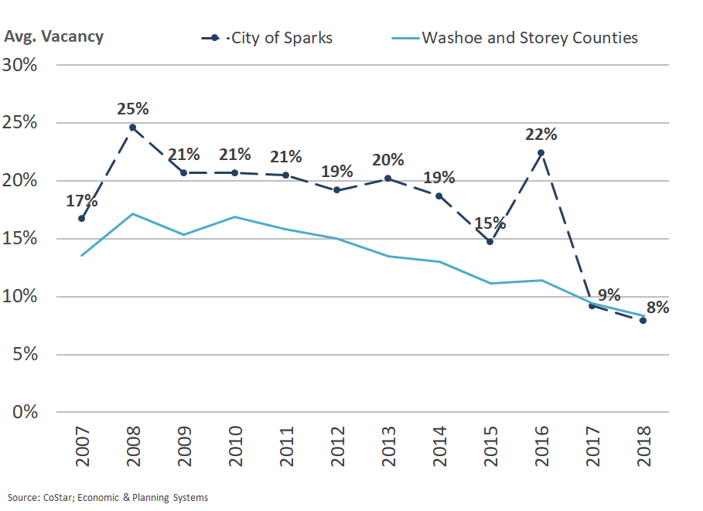

### Industrial Development

A large amount of new industrial space has been developed since 2010 in the region. However, much of the new space was developed outside of Sparks. Sparks has an inventory of 28.5 million square feet of industrial space, representing 31 percent of the regional total. The city added 1.7 million square feet since 2010, accounting for only 11 percent of the regional increase as shown in **Table 8**.

Vacancy rates for industrial space in Sparks have mirrored regional vacancy rates over the past 12 years. Vacancy rates increased from 2007 to 2010 due to the Great Recession and job losses in the region, as shown in **Figure 7**.Vacancy rates fell steadily from 2010 to 2014, reaching a low of 7.2 percent in Sparks. A large amount of new industrial space (approximately 4 million square feet) was added to the region from 2015 to 2017 but only a small amount was added in Sparks, as shown in **Figure 8**.Vacancy rates increased as the new buildings were completed but have decreased to below 10 percent at this time. The impact of the recession on the industrial market was less severe than on the office market. Vacated space was quickly leased as demand for new industrial development returned and continues to grow.

Table 8 Regional Industrial Inventory, 2010 to 2018



Figure 7 Regional Industrial Vacancy Rates, 2007 to 2018



Figure 8 City of Sparks Industrial Inventory, 2007 to 2018



### Retail Development

As of 2018 Sparks had a total retail space inventory of 6.09 million square feet, as shown in **Table 9**.The retail inventory accounts for 24 percent of the regional total. The region added 546,979 square feet of new retail space to its inventory from 2010 to 2018. Sparks added 103,802 square feet to its retail inventory during the same period, which accounted for 19 percent of inventory growth.

Table 9. Regional Retail Inventory, 2010 to 2018



Vacancy rates for retail space in the region and Sparks were above 10 percent for most of the past decade, illustrating the lack of demand for retail space. Sparks retail vacancy rates have been consistently higher than the region and peaked at 16.1 percent in 2014. However, the vacancy rate decreased significantly in the city from 2016 to 2018 as vacant space was refilled or redeveloped, as reflected in **Figure 9**. The decrease in vacancy rates to 6.6 percent now indicates new demand for space as continued employment and population growth in the region should spur new retail development in the region.

Figure 9. Regional Retail Vacancy Rates, 2007 to 2018



## Employment Growth Forecasts

The TMPRA Consensus Forecast (2018) estimates the county will grow in total employment by 94,333 jobs from 2018 to 2038. The county’s employment base is estimated to grow an annual rate of 1.4 percent during the forecast period as shown in **Table 10**.

Table 10. Washoe County Consensus Employment Forecast, 2018 to 2038



Wage and salary employment, which excludes sole proprietors, is used to estimate demand for development space. EPS applied the forecast Washoe County employment growth rate to the regional employment base to estimate demand for employment by industry from 2018 to 2038. Wage and salary employment in Washoe and Storey County are forecast by EPS to grow by 75,000 jobs over this period, as shown in **Table 11**.EPS developed estimates for annual growth rates for each industry using historic growth rates and forecasts from multiple sources (as described previously).

Table 11. Washoe and Storey County Employment Forecast, 2018 to 2038



## Employment Development Demand

EPS developed square feet per employee and floor area ratio (defined as the ratio of a building’s gross floor area to the size of the site or parcel upon which it is built) factors to convert forecast employment into demand for new building space and demand for land. The factors developed for this analysis are shown in **Table 12**.

Table 12. Non-Residential Uses Development Factors



EPS allocated jobs by industry to office, industrial or retail uses. Note that employment that generates demand for private development was estimated. Public entity employment growth was not translated into development demand. EPS estimates that the forecast 75,000 new jobs in the region by 2038 will equate to demand of 51.78 million square feet of commercial and industrial space as shown in **Table 13.**

Table 13. Forecast Regional New Development Demand, 2018 to 2038



EPS used capture rates for office, industrial, and retail space to estimate demand for new development in Sparks. The estimated capture rate for Sparks of new office space in the region is 10 percent, 30 percent for industrial space, and 25 percent of retail space as shown in **Table 14**.

Table 14. Sparks Development Capture Rates



Sparks is estimated to capture 9.0 million square feet of new office, industrial and retail space from 2018 to 2038 as shown in **Table 15**.The estimated capture of office space is 400,000 square feet, 7.1 million square feet of industrial space, and 1.6 million square feet of retail space. The new building space is estimated to require 961 acres of land to accommodate new development.

Table 15. Sparks Development and Land Demand, 2018 to 2038



1. Development Capacity

This chapter provides a summary of Sparks’ land capacity for future development. The land capacity is documented by land use and future land use designation. The estimated capacity is compared to estimated demand to determine the number of years of capacity, based on forecasts, the City currently has designated by land use type.

# Land Capacity

EPS utilized Washoe County parcel records to estimate vacant land capacity for development in the Sparks. The total vacant acres in the City’s sphere of influence, per Comprehensive Plan land use designation, were calculated. This serves as the estimate of land capacity for development. The number of vacant acres by land use category is shown in **Table 16**. The City has an estimated 3,847 acres of vacant land for development within its corporate boundary and sphere of influence. Note that land designated for open space and rural reserve is not included. EPS estimated the allocation of land by residential and non-residential uses based on the uses allowed within each land use designation within the City of Sparks Comprehensive Plan.

EPS used dwelling units per acre (DU/acre) and average floor area ratio (FAR) factors to estimate capacity for housing units and non-residential building square feet. The factors are based on the densities allowed within each land use category and typical development densities for each use type. Sparks is estimated to have capacity for 22,354 new housing units and 18.3 million square feet of non-residential buildings based on the factors used (**Table 17**).

Table 16. Sparks Vacant Acres by Land Use Designation



Table 17. Housing and Employment Use Capacity by Land Use Category



The City of Sparks land use designations were matched to the housing categories used in the TMRPA housing study and the use types used for employment uses by EPS. The corresponding categories and use types are shown below in **Table 18**.

Table 18. Sparks Comprehensive Plan Land Use Translations



For many of the non-residential and mixed-use land use categories, different non-residential uses are allowed. EPS allocated the amount of office, industrial and retail uses likely in each land use category to estimate capacity for non-residential uses. EPS estimates land capacity for office uses to be 540 acres, 426 acres for industrial uses, and 379 acres for retail uses, as shown in

**Table** 19.

Table 19. Land Capacity for Non-residential Uses



# Comparison of Demand to Land Supply

EPS estimates the demand for residential land in Sparks over the next 20 years is 1,805 acres as shown in **Table 20**. The demand for non-residential (employment) land is 961 acres over the next 20 years.

Table 20. Summary of Estimated Land Demand, 2018 to 2038



Sparks has ample land to accommodate forecast growth in aggregate. The estimated demand for land in the city from 2018 to 2038 is 2,766 acres (1,805 residential acres and 961 employment acres) while the city’s capacity is estimated to be 3,847 acres (2,502 residential acres and 1,345 employment acres), as shown in

**Table** 21.

Two land use types have demand that account for over half of total capacity. Moderate density single family demand would need 1,220 acres while capacity is 939 acres (130 percent of supply). Various housing products could likely fit into more than one of the residential housing types; therefore, lack of capacity in one given type may not be a major concern. There is land capacity of 1,412 acres of low-density single family land and only demand for 163 acres.

The second category with a lack of capacity is industrial. Sparks has estimated demand for approximately 7.1 million square feet of industrial space and capacity for only 4.8 million square feet (192 percent of supply). However, the capacity for retail and office uses is more than sufficient and could potentially be considered for other uses with limited capacity.

The employment land use category in the Comprehensive Plan having the most capacity is Employment Center, with 646 acres of capacity. However, the majority (64%) of land designated Employment Center is within four Planned Developments (PDs). The four PDs are Stonebrook, Kiley Ranch, Copper Canyon, and Pioneer Meadows. The development handbooks for these four projects specify the types of employment uses allowed in the Employment Center Areas. The handbooks all designated these lands for Business Park uses, which allow only a limited amount of uses and building types that are considered to be within the industrial demand estimate. EPS conservatively estimates 50 percent of the Employment Center designated lands is for industrial uses; however, the true amount may be less. The analysis did not assess how “development ready” the industrial sites are.

For Washoe County as a whole, TMRPA completed an Industrial Land Needs Analysis in 2013. The study found the region lacked development ready industrial sites to accommodate demand. The study contained a more in-depth analysis of capacity and suitability of industrial lands.

Table 21 Comparison Land Demand to Capacity



Figure 10 Sparks Developable Land Capacity

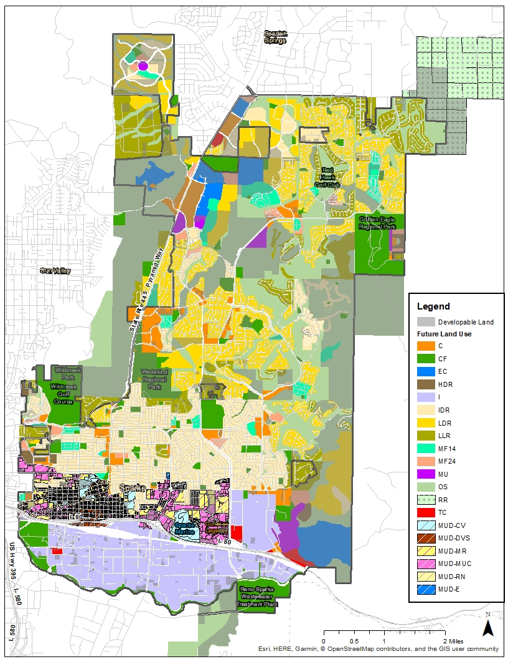

1. Long-Term Fiscal Impacts

The long-term fiscal impacts of the forecast development demand in Sparks over the next 20 years are summarized in this chapter. The growth forecasts and development demand estimates were used to assess the impact on the City’s General and Road Funds using the fiscal model developed for this project. Forecast new development was phased over the 20-year period according to annual demand estimates. This draft report provides the assessment of a baseline growth forecast and development scenarios. The model can be used to test alternative scenarios based on input from City staff.

The fiscal impact model used to test the fiscal impacts of the forecast growth was developed by EPS in the initial phase of this effort. A summary of the model approach and methodology is provided in a separate memorandum (Fiscal Impact Methodology). A second memorandum details recommended guidelines for applicants to use when preparing a fiscal impact analysis for submittal to the City with certain land use applications such as annexations and Comprehensive Plan land use amendments (Fiscal Impact Guidelines).

# Baseline Forecast Fiscal Impact

EPS used the estimated demand for residential and non-residential uses summarized in Chapter 2 to estimate the future fiscal impact of the City’s land use plan. The estimated 12,200 residential units to be added to the city by 2038 were entered into the model by housing product type (single family, attached/townhome, mixed-use residential, and multifamily residential). The estimated demand for 9.07 million square feet of non-residential development demand was entered into the model using the categories of Retail/Restaurant (1.56 million square feet), Office (402,237 square feet), and Industrial (7.1 million square feet). Average market values for new development for each type were used to estimate property tax. New development is estimated to be built proportionally over 20 years. Lastly, the densities used to estimate demand and capacity are applied to the forecast new development and the model followed the approach and factors provided in the Fiscal Impact Guidelines.

The fiscal impact of the baseline forecast on the General and Road Funds are shown in **Table 22**. The baseline forecast is estimated to generate an average annual net fiscal positive impact on the General fund of $3.3 million. The average annual impact equates to a net positive impact of $66.7 million over 20 years.

The fiscal impact of the baseline forecast on the Road Fund is estimated to be negative by $4.0 million annually over 20 years. The total net fiscal impact is a negative $80.4 million. It should be noted that the factors used to estimate costs to maintain roads (which is paid for through the Road Fund) reflect the estimate total cost per square foot of roadway for on-going maintenance and roadway capital repairs for the estimated life of the pavement. The costs do not reflect what the City currently spends on roadway maintenance and capital repair.

The annual net fiscal impact on the General Fund and Road Fund is illustrated in

**Figure** 11over a 30-year period to illustrate the impacts after stabilization and results in a net positive fiscal impact.

Table 22. 20-Year Fiscal Impact of Baseline Forecast



Figure 11 Baseline Forecast Annual Net Fiscal Impact (30 years)



# Fiscal Impact Alternative Scenarios

EPS tested four alternative scenarios within the fiscal model to illustrate how differences in growth patterns and the balance of residential and non-residential uses impacts fiscal health. These scenarios reflect current pressures and growth patterns the City of Sparks is experiencing or of the intended land use pattern defined in the larger undeveloped PDs within the city. The fiscal impact of each scenario, compared to the baseline, is provided in **Table 23**.The four alternatives are described below.

* **Industrial Constrained** –The baseline assumption assumes the estimated demand for industrial space in Sparks of 7.1 million square feet will be accommodated through redefinition of allowed uses in PD handbooks and/or through changes in land use designations to accommodate demand despite the lack of land capacity for this specific use. The Industrial Constrained scenario assumes that the lands designated for employment center remain as planned and only 4.8 million square feet of industrial area accommodated.
* **Increase in Residential Uses –** The City of Sparks has been receiving requests for conversion of employment lands to residential uses. This scenario assumes the total capacity for single family homes is increased through conversion of excess employment lands to allow for 14,640 units (a 20% increase in each residential type) and is absorbed over 20 years.
* **Increase in Business Park** – As mentioned previously, a large portion of the City’s land designated for Employment Center is in four PDs that designated these lands in their development handbooks for “Business Park” or “Employment Center” uses that more closely align with more office-oriented uses than industrial. This scenario assumes that these developments are successful in capturing a greater share of regional office development than estimated. The capture of office uses is estimated at 1.2 million over 20 years. As a result, industrial space in Sparks is constrained to 4.8 million square feet based on existing capacity for industrial uses.
* **10% Increase in Density** –The average density of all uses is 10 percent greater. The average floor area ratio for non-residential uses is increased 10 percent and the average unit per acre is increased as well. The increase in density reduces the roadway needs per housing unit or non-residential building.

Table 23 Fiscal Impact of Alternative Scenarios



The alternatives have a mixture of impacts on both the General and Road Funds. The analysis identifies that there is no one land use that if increased or decreased in a significant amount will greatly change fiscal conditions. EPS identified two primary findings related to the alternative analysis.

* The first finding is that increased density of development and/or developing a greater proportion of denser uses (e.g., multifamily vs. single family) reduces the negative fiscal impact of development. There are two reasons for this. First, the cost to provide service is less slightly less for services provided in the General Fund. Second—and most impactful—is that denser uses generate less roadway for the City to maintain. The net impact (General Fund Impact plus Road Fund Impact) of the **10% Increase in Density** alternative reduces (i.e., improves) the net negative impact by 59 percent.
* The second finding is that a balance between employment and residential growth is needed to support fiscal health. Each use has varying impacts on the General and Road Funds; however, employment uses (office and industrial) generally generate a positive impact to the City that can offset negative impacts from other uses. The **Industrial Constrained** alternative exacerbates the net negative fiscal impact by 23 percent and the **Increased Residential** alternative increases the net negative impact by 12 percent. These two scenarios illustrate that if housing and employment growth are not balanced, there are greater negative fiscal impacts. The **Increased Business Park** alternative illustrates two findings. First, the increased capture of office uses in this scenario offsets the impacts of the limited industrial growth in the **Constrained Industrial** alternative. Second, the swapping of more office-oriented employment uses for industrial-oriented uses results in a relatively neutral impact on the City overall, assuming traditional suburban level density for the office development. This means that employment growth, either office-oriented or industrial-oriented, generates relatively the same benefits. It should be noted, however, that retail uses generally have a more negative impact on the General Fund than office or industrial uses due the increase of traffic and police calls these uses generate.

The analysis of fiscal impacts of the growth alternatives illustrate that a balanced land use plan is needed to maintain fiscal health. The City’s current land use plan adequately balances growth but efforts are needed to ensure employment uses are attracted to planned sites at the same rate as residential uses. As well, the analysis illustrates that the City lacks industrial lands which can have an impact on future fiscal health if either increased capacity is not created or alternative employment uses are not attracted. Lastly, the cost and impact of maintaining local roadways significantly impacts fiscal health. Development that generates more roadways for the City to maintain is more impactful if the density and intensity of development along those roadways is relatively limited.